ABSTRACT TITLE ( Bold 14pt centered)

Author, A¹, Author, B², and Author, C³ (12pt centered)
¹Affiliation 1(12pt centered)
² Affiliation 2 (12pt centered)
³ Affiliation 3 (12pt centered)
E-mail (corresponding author)

In line with the theme of the 4th National Civil Engineering Symposium, authors are invited to submit abstracts for oral or poster presentations on topics relevant to the conference theme. Authors must submit an abstract not exceeding 200 words, written in English. The abstract should provide a concise summary that includes the problem statement, specific methods used, significant results, and conclusion. The official Abstract Template must be used, and authors should ensure that only text is included—no paragraphs are permitted. The abstract must be submitted as an editable Microsoft Word document (.doc or .docx). To ensure broad compatibility, the latest Word file format should be avoided. The filename should be formatted as: “SURNAME OF THE FIRST AUTHOR – NCE2026 – ABSTRACT”. If an author submits more than one abstract, each filename should include an abstract number after the surname. After submission and evaluation, accepted abstracts will be assigned an abstract number, which will be communicated to the authors in the acceptance letter.

Keywords: up six keywords to be defined. The keywords to be sperated with semicolon, eg. Symposium;NCE2026;Abstract etc.
(1 line spacing here)
- INTRODUCTION (headlines: Bold, 12pt)
In conjunction with the 3rd National Civil Engineering Symposium theme, papers of relevant topics within the conference theme are invited for oral/poster presentations. Authors are requested to submit an extended abstract not exceeding two (2) pages in English.
The extended abstract must include the title, author(s) introduction, material and methods, results and discussion, conclusion and references. The manuscript should be prepared on an A4-sized paper with 25 mm margins on all sides and typed with single spacing using size 12 Times New Roman font. All illustrations must be prepared inside of the main text.

- MATERIALS AND METHODS (headlines: Bold, 12pt)

The methodology must be clearly stated and described in sufficient detail or with sufficient references.

- RESULTS AND DISCUSSION (headlines: Bold, 12pt)
The findings and arguments of the work should be explicitly described and illustrated.
All the tables, images and figures should be centered. Figures and images should be numbered and figure headers should be placed under the figure or image; as for the tables, they should also be numbered and the table header should be placed at the top. References (if any) of the tables, figures and images should be presented right under the tables, figures and images in the form of author surname and publication date.

- USING THE TEMPLATE FOR SEVERAL COMPONENTS (headlines: Bold, 12pt)

4.1 Equations
Equations should be centered and numbered consecutively, as in Eq. [1]. An alternative method is given in Eq. [2] for long sets of equations where only one referencing equation number is wanted.
 |  | [1]
where, | (1 line spacing here)
 |  | [2]
(1 line spacing before and after equations)
  - Tables and figures
Tables and figures should appear in one column of a page and be numbered consecutively. Figures and texts may appear on the same page, and a centered caption should appear directly beneath the figure. It is preferable that figures be mounted in portrait style and figure captions are no longer than two lines. On figures showing graphs, both axes must be clearly labeled (including units if applicable).
Tables should be designed to have a uniform style throughout the paper, following the style shown in Table 1. Table captions should be in 10pt “Time News Roman” bold, centered, and the texts in Table should be set in 9pt “Time News Roman” font.
(1 line spacing here)
Table 1. Caption heading for a table should be placed at the top of the table and within table width.
(Use “time news roman” font, size 10pt, No spacing after table title)
 | A | B | C | D
A | Aa | Ab | Ac | Ad
B | Ba | Bb | Bc | Bd
C | Ca | Cb | Cc | Cd
D | Da | Db | Dc | Dd
E | Ea | Eb | Ec | Ed
(1 line spacing here)
Authors are advised to prepare their figures in either black and white or color. Please prepare the figures in high resolution (300 dpi) for half-tone illustrations or images. Pictures must be sharp enough otherwise they will be rejected. Figures must be originals, computer-generated or drafted, and placed within the text area where they are discussed. Figure 1 shows one example. Figure captions should be in 10pt “Time News Roman” font, bold, centered. When applicable, the texts in graphs, illustrations or images should be set in 8pt “Time News Roman” font.
(1 line spacing here)
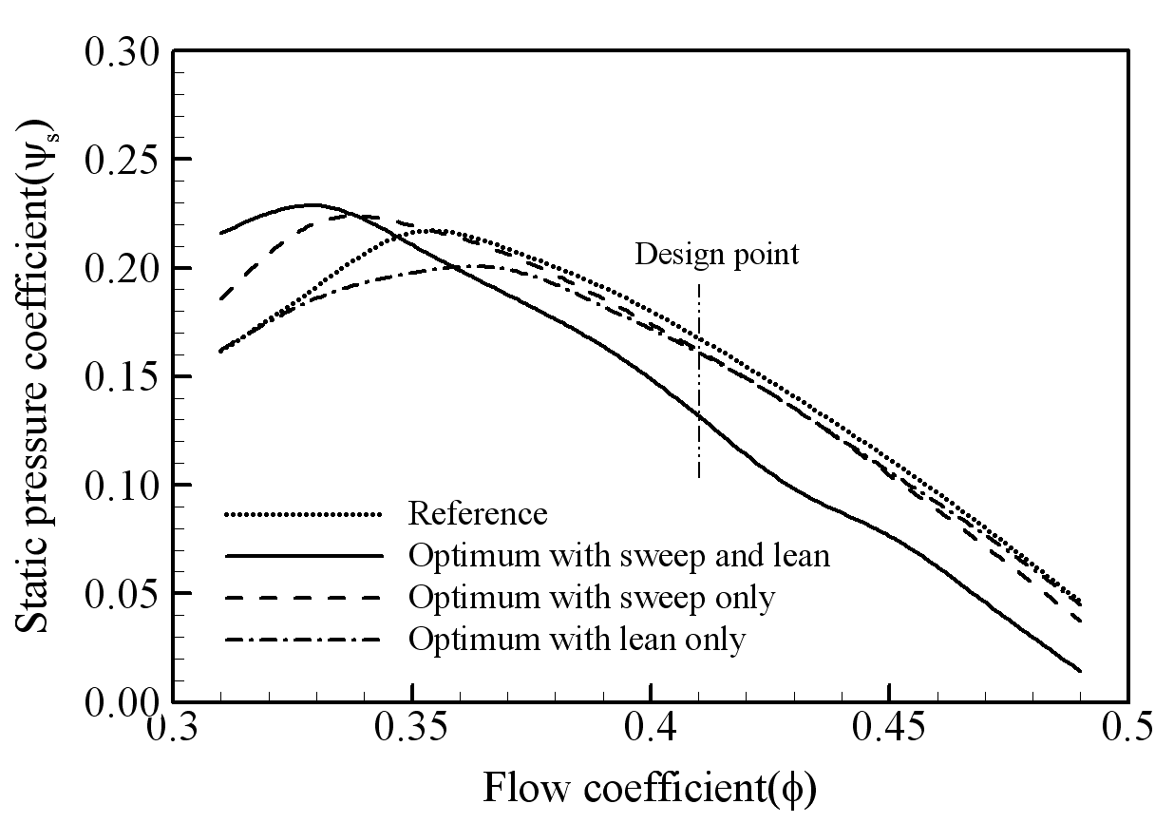
Figure 1. The caption heading for a figure should be placed below the figure and within figure/illustration width. (Use “Time News Roman” font, size 10pt, no spacing between title and figure)
(1 line spacing here)
  - Footnotes
Footnotes are denoted by a character superscript in the text b.

  - Units
Use either SI as primary units. English or CGS units may be used as secondary units (in parentheses). Avoid combining SI and CGS units. This often leads to confusion because equations do not balance dimensionally. If you must use mixed units, clearly state the units for each quantity that you use in an equation. Do not mix complete spellings and abbreviations of units. Spell out units when they appear in text.

CONCLUSION (headlines: Bold, 12pt)
Conclusions should include (1) the principles and generalisations inferred from the results, (2) any exceptions to, or problems with these principles and generalisations, (3) theoretical and/or practical implications of the work, and (5) conclusions drawn and recommendations.

ACKNOWLEDGMENT (headlines: Bold, 12pt)
The authors would like to express appreciation for the support of the sponsors [Project Number = XXXXXXX].

REFERENCES (headlines: Bold, 12pt)
In the text, place the author’s surnames (without initials) and the year of publication in parentheses (Gibson & Henkel, 1954). At the end of the paper, list all references in alphabetical order. If several works by the same author are cited, entries should be chronological. If there are more than two references by the same first author in the same year, the year is followed by a character in alphabetical order, e.g., 2010a and 2010b as in:

Larch, A.A. 1996a. Development ...
Larch, A.A. 1996b. Facilities ...
Larch, A.A. 1997. Computer ...
Larch, A.A., Jensen, M.C. 1996. Effects of ...
Larch, A.A., Smith, B.P. 1993. Alpine ...

Please use the following formatting for the references.
Last name, Initials year. Title of article. Title of Journal volume number (issue number): page numbers.
Last name, Initials year. Book title. City: Publisher.

Examples:
Gibson, R.E., Henkel, D.J. 1954. Influence of duration of tests at constant rate of strain on measured “drained” strength. Géotechnique 4 (1): 6-15.

Grove, A.T. 1980. Geomorphic evolution of the Sahara and the Nile. In M.A.J. Williams & H. Faure (eds.), The Sahara and the Nile: 21-35. Rotterdam: Balkema.

Jappelli, R., Marconi, N. 1997. Recommendations and prejudices in the realm of foundation engineering in Italy: A historical review. In Carlo Viggiani (ed.), Geotechnical engineering for the preservation of monuments and historical sites. Napoli, 3-4 October 1996. Rotterdam: Balkema.

Johnson, H.L. 1965. Artistic development in autistic children. Child Development 65(1): 13-16.
Polhill, R.M. 1982. Crotalaria in Africa and Madagascar. Rotterdam: Balkema.

b Just like this one.

